To help you start, write concrete examples of your data

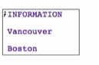

Go to: <https://courses.edx.org/courses/course-v1:UBCx+HtC1x+2T2017/77860a93562d40bda45e452ea064998b/#HtDD>

Scroll over and you’ll see a guide on how to represent the concrete examples (information) that you have provided a while ago

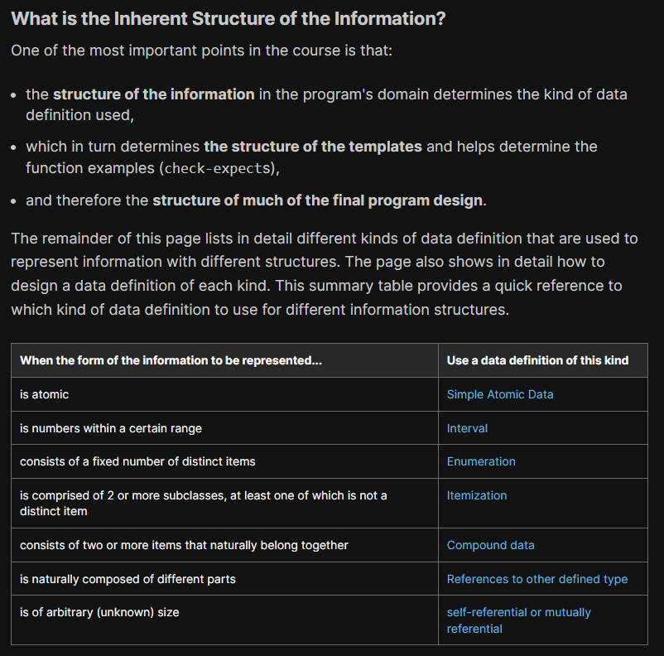

In our case, city names are atomic

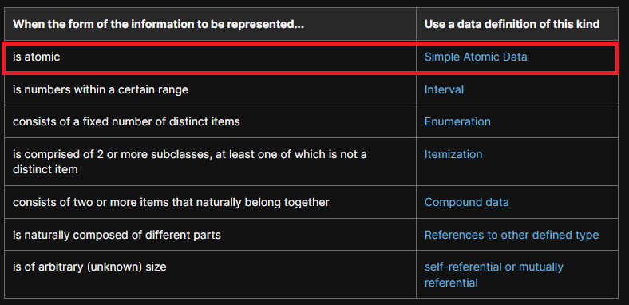

* Can’t take it apart into pieces anymore
  + Meaningfully part of the same problem domain
  + Eg. Boston -> “Bos” or “ton” is not really a city name anymore which is our problem domain

Click on Simple Atomic Data link on the table

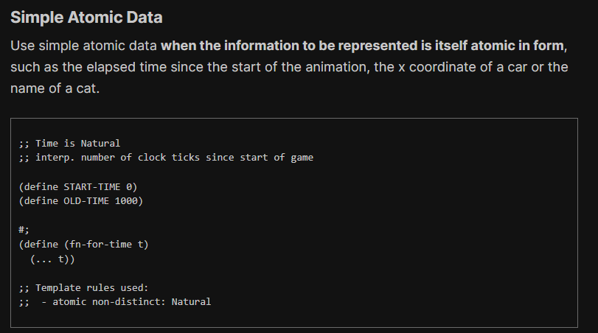

Going back to DR Racket with the steps of the HtDD

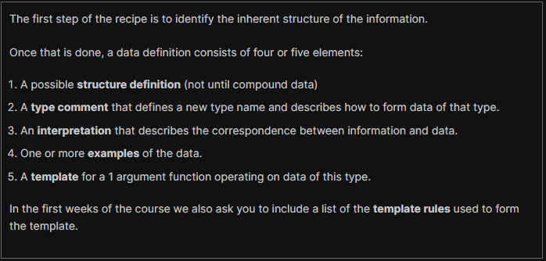

Skip structure definition first (not until compound data)

**Type comment**



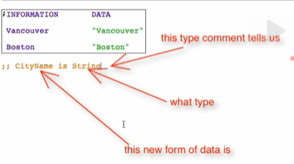

**Interpretation**



**Examples**



**Template**

Go back to the design recipes page: <https://courses.edx.org/courses/course-v1:UBCx+HtC1x+2T2017/77860a93562d40bda45e452ea064998b/#Atomic>

Click on Data Driven Templates

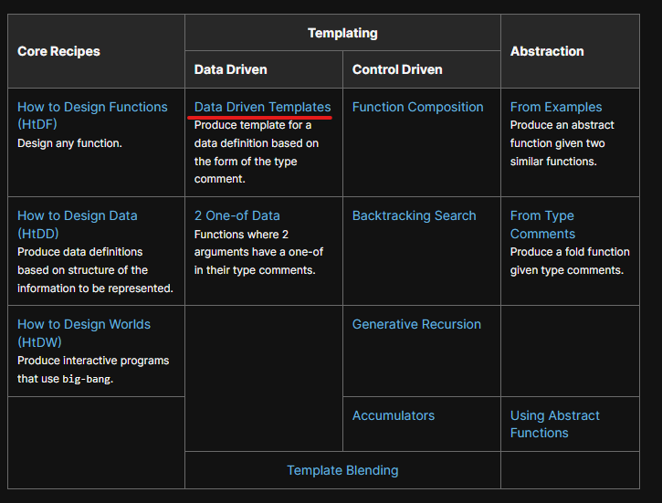

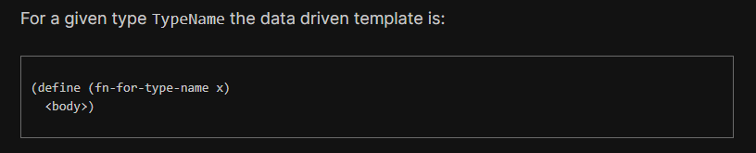

Apply and determine template rules

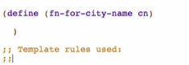

Check for the template rules around here: (just right below the template above)

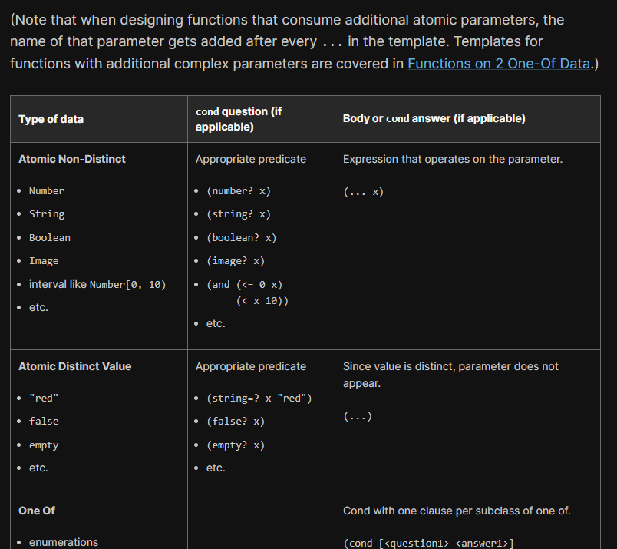

Check the primitive/typeof of your data

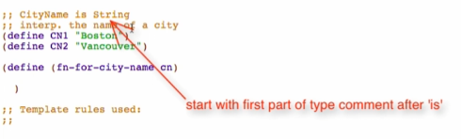

* This is where you’ll start searching for the body
* String is an Atomic Non-distinct

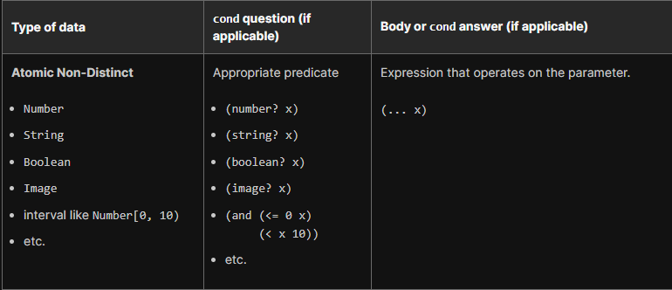

So the body of the template would be (… cn) and add your template rule

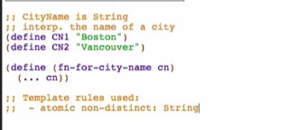

Run to check for syntax errors

Clean your work

Comment out the template after checking for syntax errors



Delete the concrete examples too

